# Plot of Events’ PSD in function of time for each electrode

# /Users/kientzelise/Downloads/WhatsApp Image 2018-04-25 at 17.24.53.jpeg

To get these figures we average the PSD values of each events (both feet and both hands). The repartition of electrodes on the 16-electrods cap is as follow:

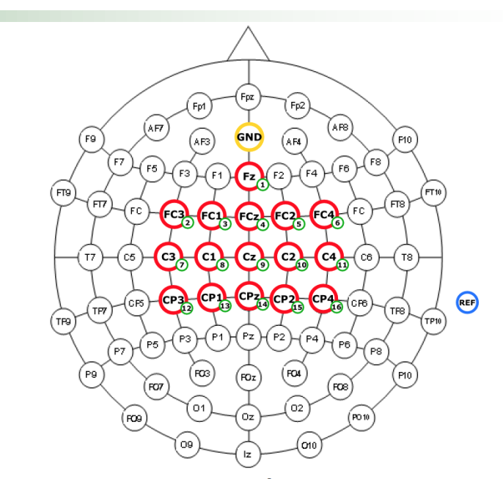

As we know that motor cortex for hands movement planning is situated on lateral sides of the brain, we expect to see a differentiation in the PSD behavior for Event “Both Hands” in Electrodes 7 or 11. For a feet movement planning, we expect to see changes in Electrode 9.

On this figure we represented the PSD for both hands (BH) and both feet (BF) events from the fixation event to the end of the continuous feedback event. We represented the end of the Fixation event by a vertical green dashed line which gives a “start” for the movement planning.

Indeed, we see that for electrode 7 a net distinction can be made between BF and BH events as the data corresponding to the BH events decrease “considerably” compared to data corresponding to the BF events. As we know, a decrease in PSD value corresponds to a desyncronisation of the cortex neurons.

We can see the same phenomenon in Electrode 11, with less separability than for Electrode 7.

In electrode 9, we do not see any difference between BF and BH events.

Electrode 8 and Electrode 10, which are near to the motor cortex area for BH event planning also show a desynchronization for BH event.

The only electrode that shows a desynchronization for BF event is the Electrode 14. Its position, near to the one predicted to be relevant for BF event detection (Electrode 9) can in parts attests the planning of a BF event rather than a BH event.

For future steps, these figures can help us determining which electrode is useful to classify our event. If we focus for example on electrode 7, 11 and 8 : we could determine if the measured signal corresponds to a BF or a BH event planning.

# ERD/ERS Topoplot

To calculate the ERD/ERS average for each cue class, I calculated the ERD/ERS for each motor imagery action. Using therefore the specific PSD of continuous feedback and fixation period for each single cue. The ERD/ERS was then calculated as follow:

ERD % = 100 (log A − log R ) / R

Then the single cue ERD/ERS were averaged to obtain a class ERD/ERS.

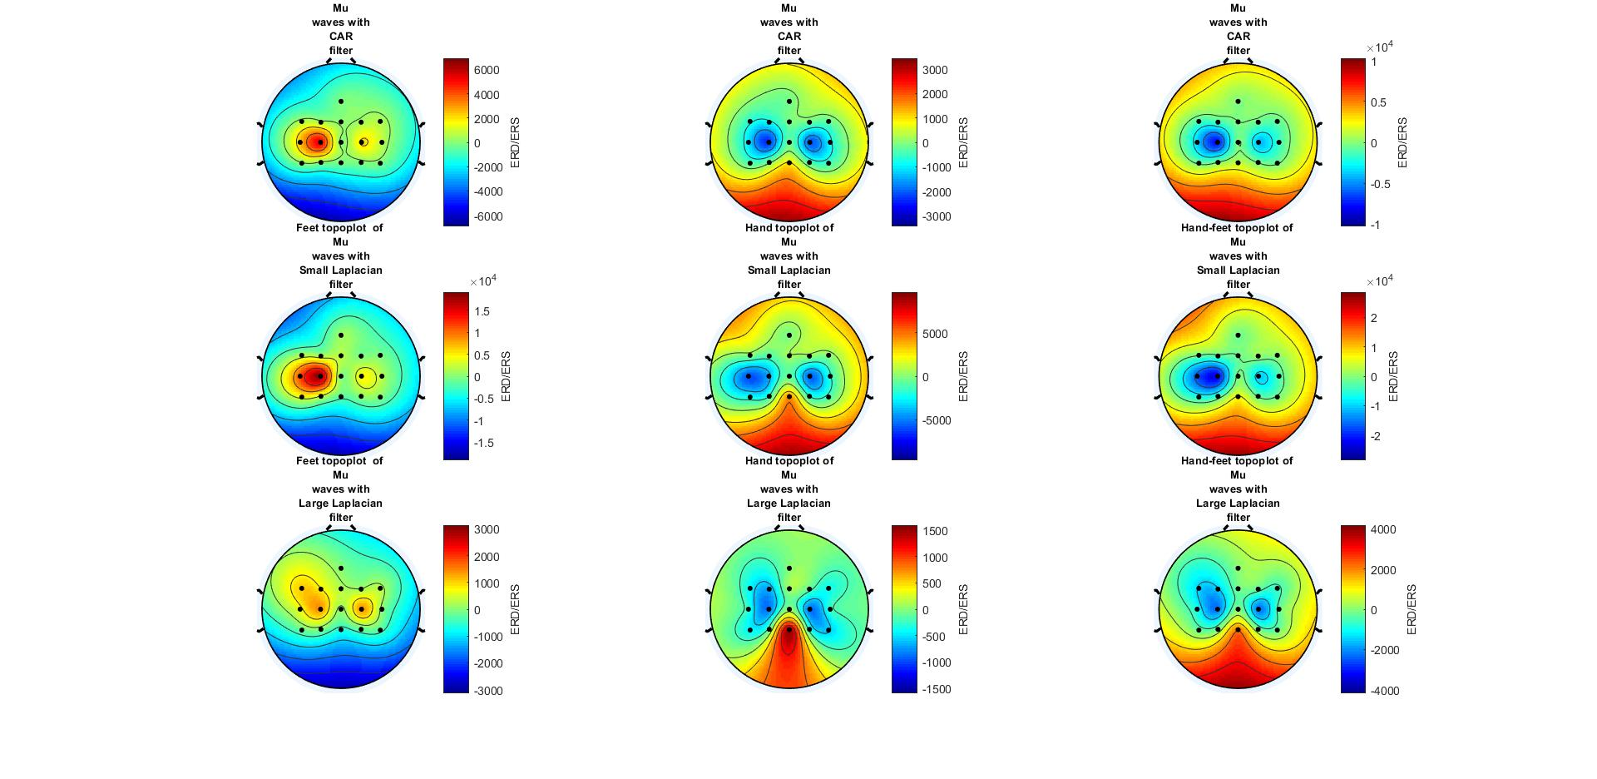

Topoplot of MU wave brain activity using three different spatial filter (CAR,Small Laplacian,Large Laplaci) . On the left are the “Feet”cue ERD/ERS, in the middle the “hand” cue ERD/ERS and on the left the ERD/ERS difference between the two events (Hand-feet).

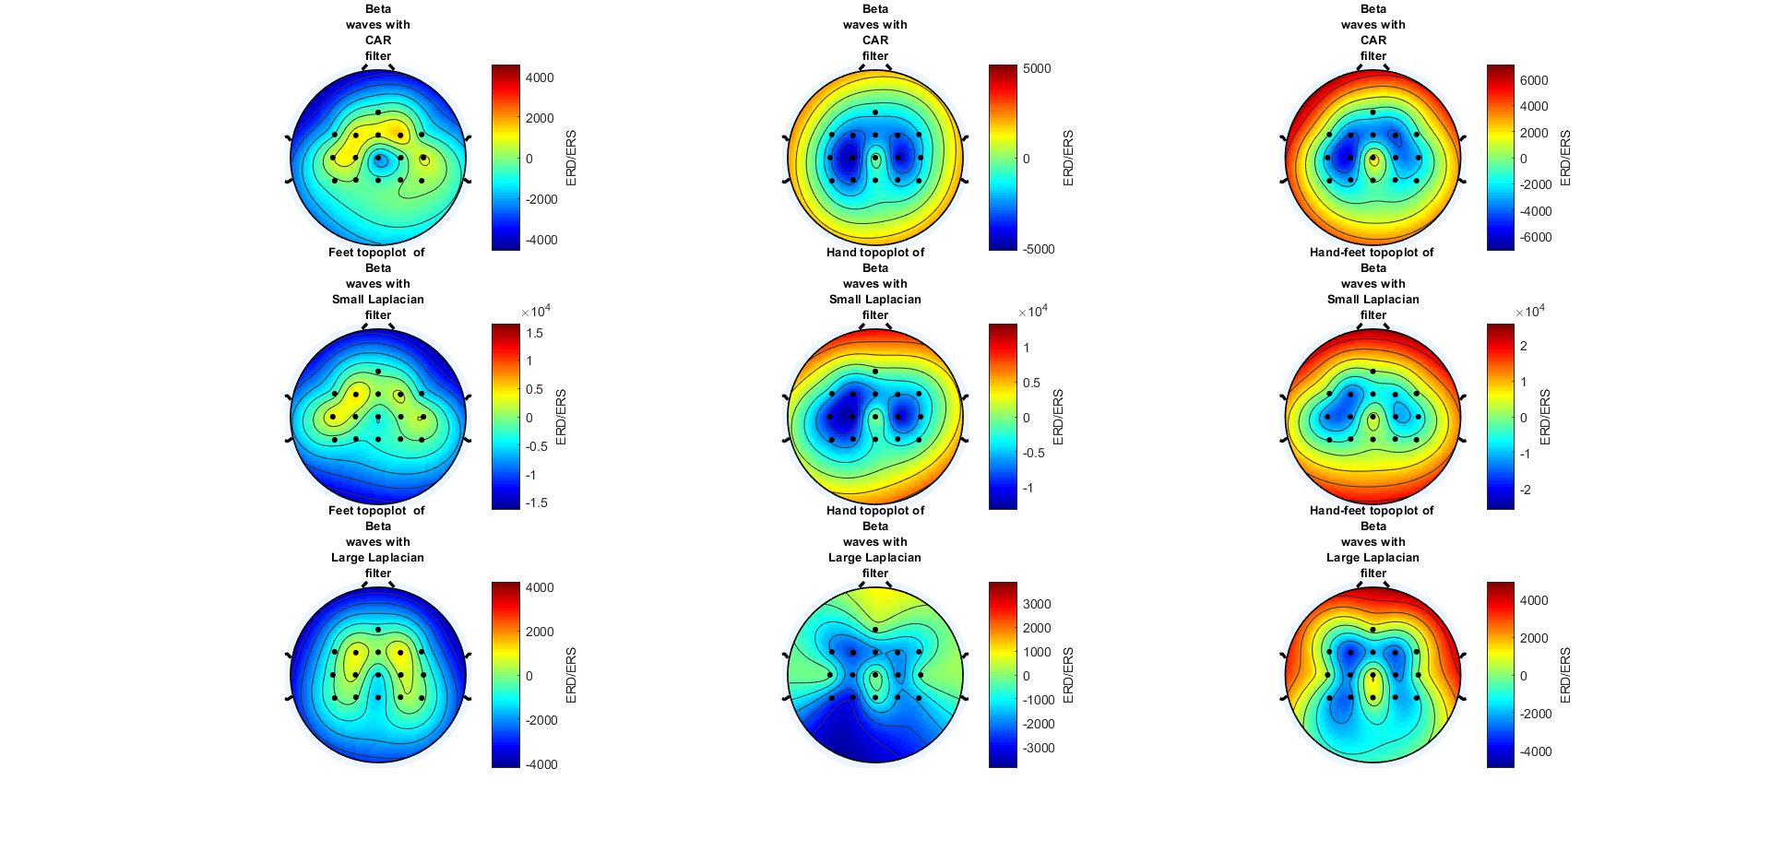

Topoplot of BETA wave brain activity using three different spatial filter (CAR,Small Laplacian,Large Laplaci) . On the left are the “Feet”cue ERD/ERS, in the middle the “hand” cue ERD/ERS and on the left the ERD/ERS difference between the two events (Hand-feet).

Regarding the Mu band we can clearly see a decrease power measured by the lateral electrodes regarding the central electrode for the three filters for the hand cues (as expected. For the feet cues, we see a lower ERD/ERS for the middle electrodes than for the lateral ones. But we don’t see a negative ERD/ERS which should happen as there should be desynchronization of the neuron and therefore a weaker power during the feedback compared to the fixation for the activated area.

Regarding the Beta band, we can observe a weaker ERD/ERS of the lateral electrode compared to the central electrodes for the hand cue. On the opposite, for the feet cue you can observe a decrease ERD/ERS for the central electrodes.

With those results it seems that cues could be discriminated by observing the mu waves. By computing the signal difference between lateral and central electrode we should be able to discriminate hand cues by a decrease PSD during feedback compared to fixation. For feet cues, the result is less pronounced as there is no decrease compared to the feedback for the central electrode but rather an increase PSD for the lateral electrodes.

We could use the beta band ( that reflect concentration) to increase the detectability of feet cues as there is a desynchronization ot the central part of the brain for this frequency band.

Finally the filter choice is not critical, nevertheless the large Laplacian works best for beta waves and for the mu waves the impact of the filtering is smaller